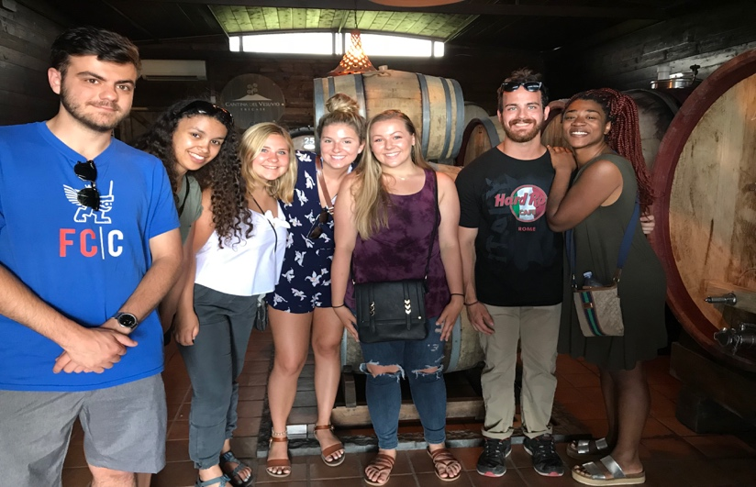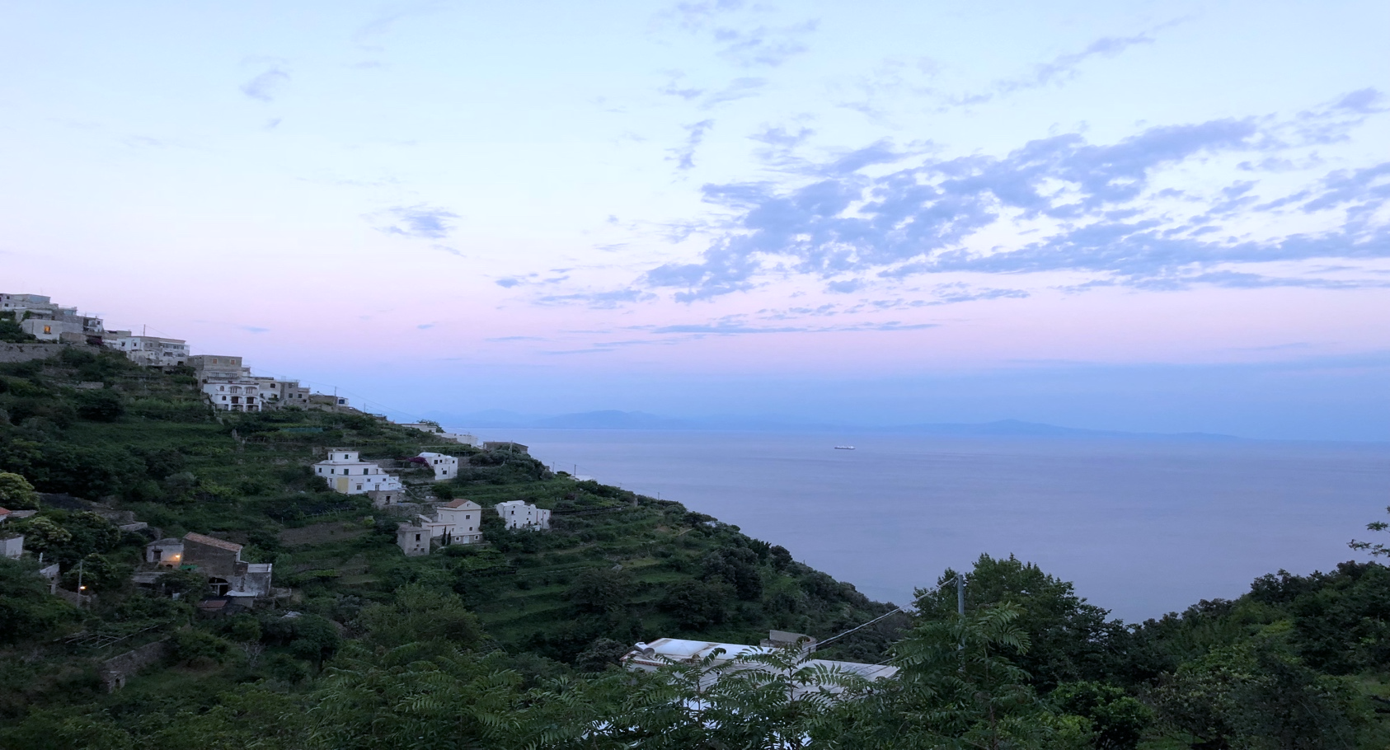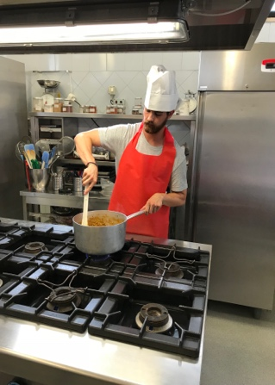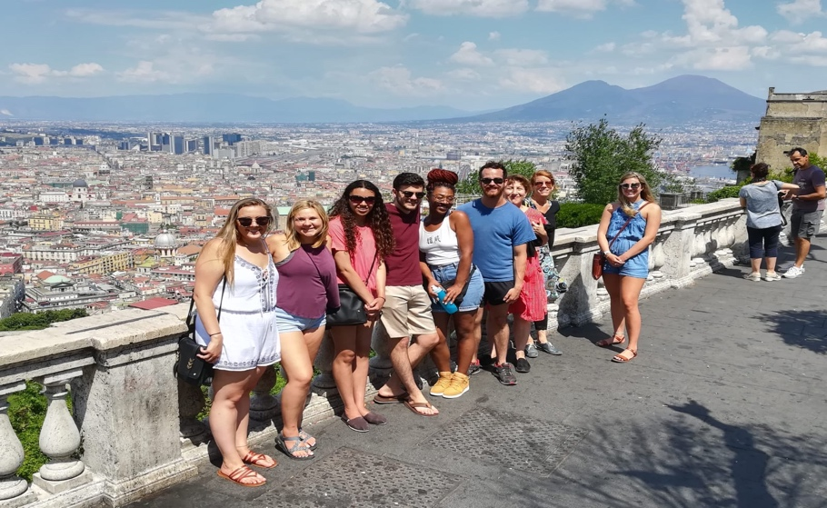

712 Old Chem

Phone: (513) 556-1950

Fax: (513) 556-2577

**Romance Languages & Literatures**

University of Cincinnati

P.O. Box 210377

Cincinnati, OH 45221-0377

Open to all UC students that are in good standing

* Summer Semester: MLTI 3000 -- 4 Humanities credit hours
* Spring Semester: ITAL 2061-001 – 2 Humanities credit hours

**Travel Dates**

**Friday June 14th** (departure date from the United States THURSDAY June 13th) to **Friday June, 28th**

**Application**

**Applications are due** **March 1, 2019**. Italy: Sea, Sun & Soul in NAPLES 2019 is a popular travel-study destination and fills quickly. A limited number of qualified students are accepted into the course in the order in which they apply – so get your application in soon for an interview!

ITALY SEA, SUN, & SOUL

Naples 2019

**A 15- day adventure into Italian language and culture offering 4 Humanities credit hours.**

Contact course director **Joyce Miller** at **mja@ucmail.uc.edu**

*$2660 includes shared apartment housing, weekend and daily excursions and culture tours, Centro Italiano Napoli tuition and books, ground transportation from Napoli airport or train station, in country transportation (metro passes), and most evening meals. Students will be responsible for international airfare, personal phones, and the UC $200 MLTI300 fee. A UC Study Abroad grant of $400 is awarded to each student.

**For more information….**

**Estimated Cost**

**Course Details**

Study Italian in Naples, Italy with students from around the world at [Centro Italiano Napoli.](https://www.centroitaliano.it/) Students will live in the center of Naples just a short walk from the sea. A 15-day cultural and learning extravaganza that includes a visit to the ancient city of Pompeii.

**About the program**

Your text here

Your text here