UC Arabic Summer Program in Morocco
June 9th – July 6th, 2019
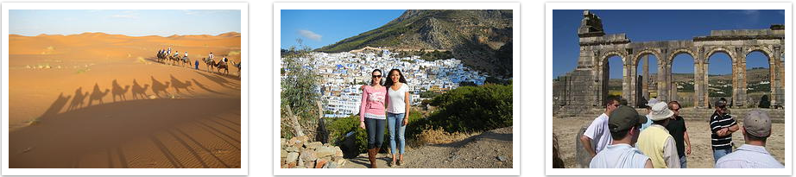
Come learn Arabic in magic Morocco! 4 weeks Language and Culture program offering 8 Credit Hours. Learn Arabic Language and culture in Rabat Morocco with students from around the world at “Qalam Wa Lawh” Institute

Course Details: Open to all UC Students in good standing
Classes: Language: ARAB 1001-005 (5 cr.) & Culture: ARAB1010-001 (3 cr.)
Note: These courses may be used toward a minor in Arabic Language and Culture.
Estimated Total Cost: $4,100.00 (Total approx. cost, before UC Int. block grant)
Grants: First 10 participants receive $400.00 UC Int. block grants

The cost of $4,100.00 includes:

- Language and culture courses fees (including ARAB 1001 and ARAB 1010)
- UC International fee for MLTI3000 course
- Health Insurance and ISIC Card
- Housing: Host Family Accommodations (Single room, breakfast and dinner / Lunch (School lunch))
- Cultural Immersion Activities, Calligraphy, Workshops, Lectures
- 3 Weekend Trips (Fes, Meknes, Volubilis, Chefchaouen, Tangier, and the Sahara)
- Welcome Ceremony / Orientation & Farewell Ceremony / Graduation
- Casablanca / Rabat Airport Transfer (Pick-up and Drop-Off)
International airfare is not included; students must purchase their own plane tickets for this program

Applications due February 22nd, 2019. Spots will fill quickly! So, fill your application as soon as possible to start the process and getting your interview confirmation.
Apply Here: http://studyabroad.uc.edu/index.cfm?FuseAction=Programs.ViewProgram&Program_ID=10304

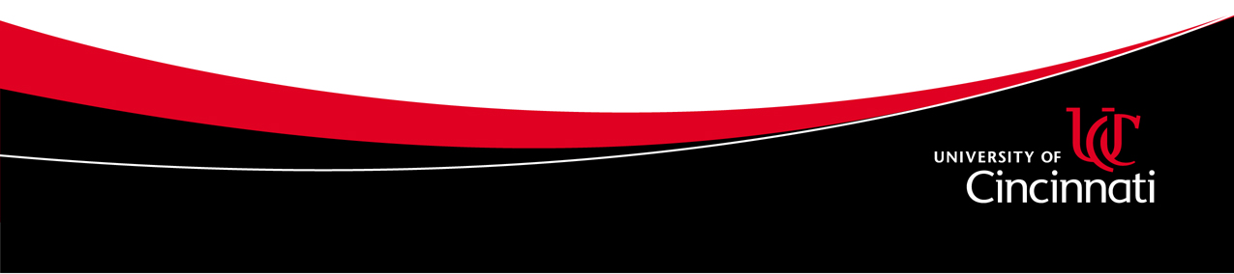
More info: Mohamed Elayyadi at: Elayyam@ucmail.uc.edu or
Grace Thome at: Thomege@ucmail.uc.edu

